Incrimental-loading sql to sql
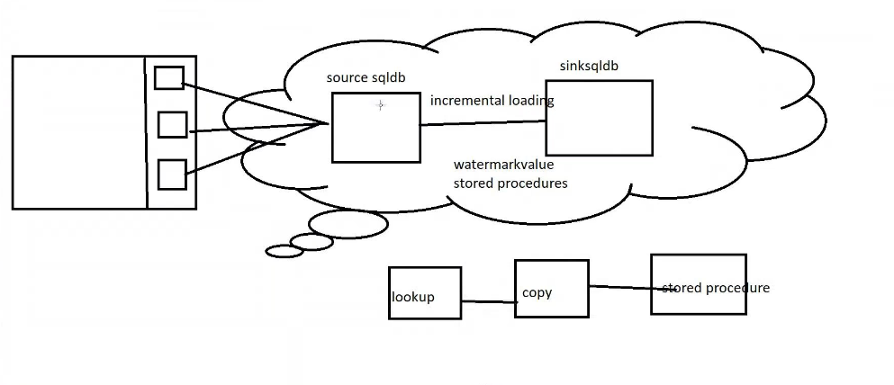
Create source side database:
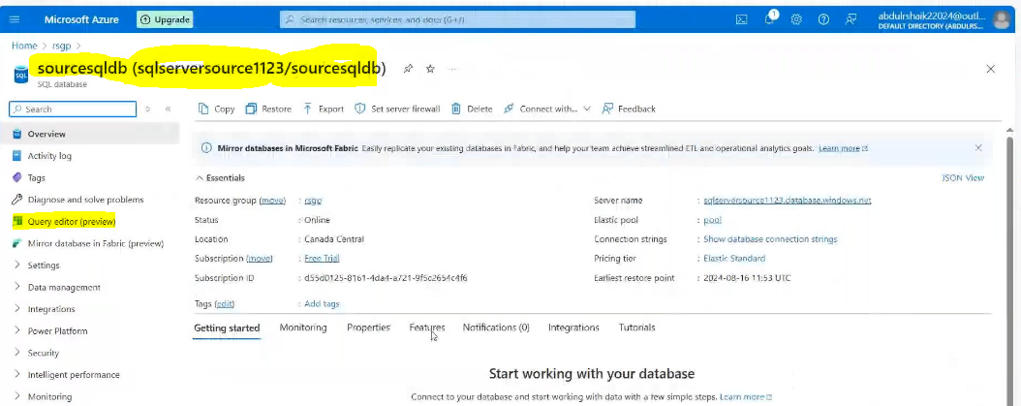
Create sink side database:

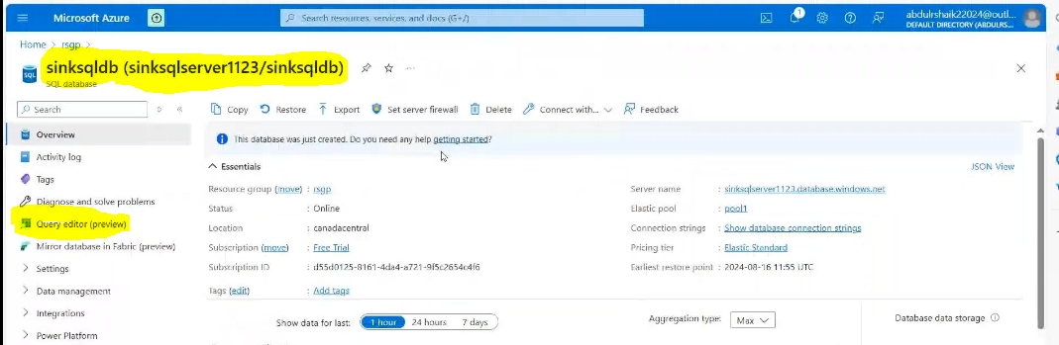
Create Adf:
Then create linked services:
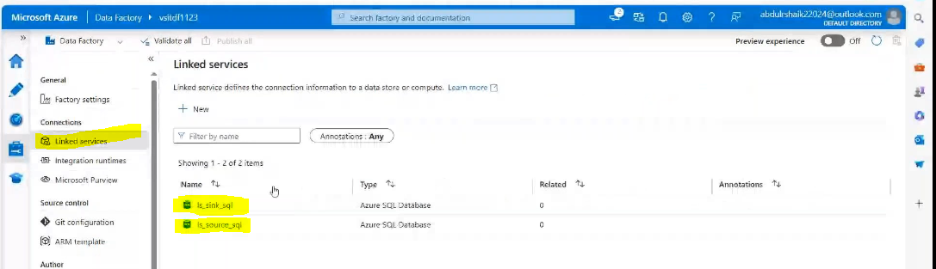
Then create databases for both sides: source side and sink side:
Next source side sql database connected to the sssms:
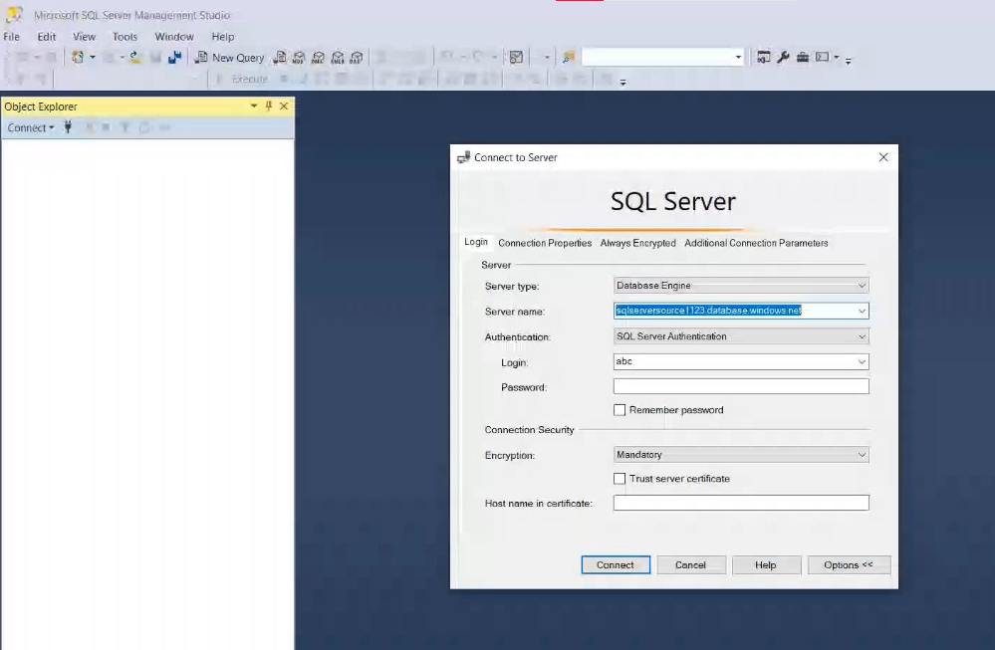

Go to source sql database:
Then create table along with last modify time value
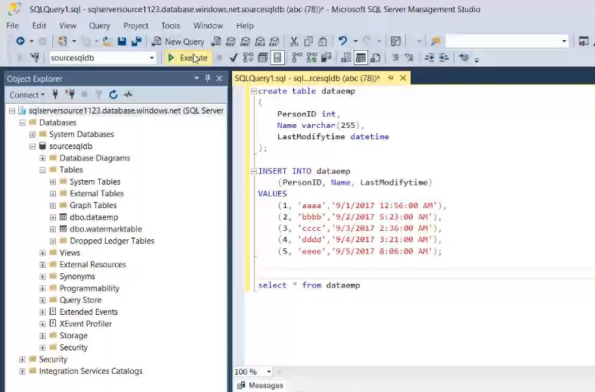
Create watermark table :
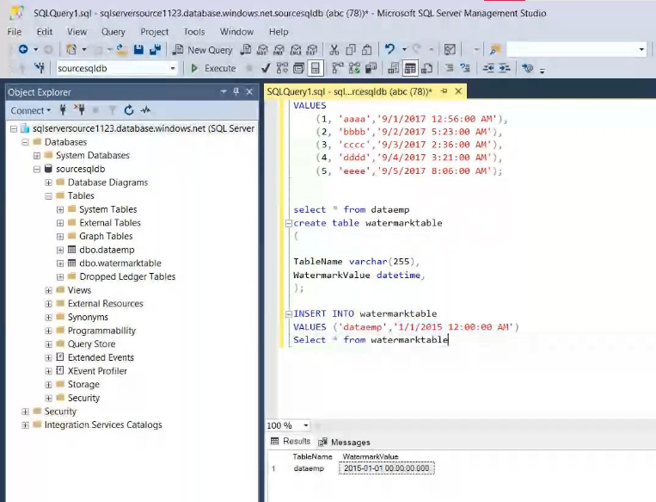
Create stored procedure:
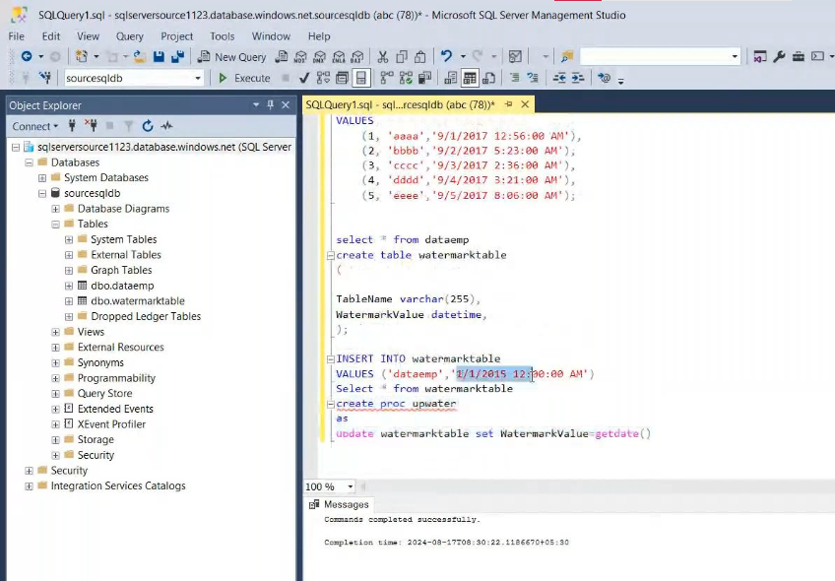
Then create pipeline and Drag and Drop the lookup activity:
Create dataset for look up activity:

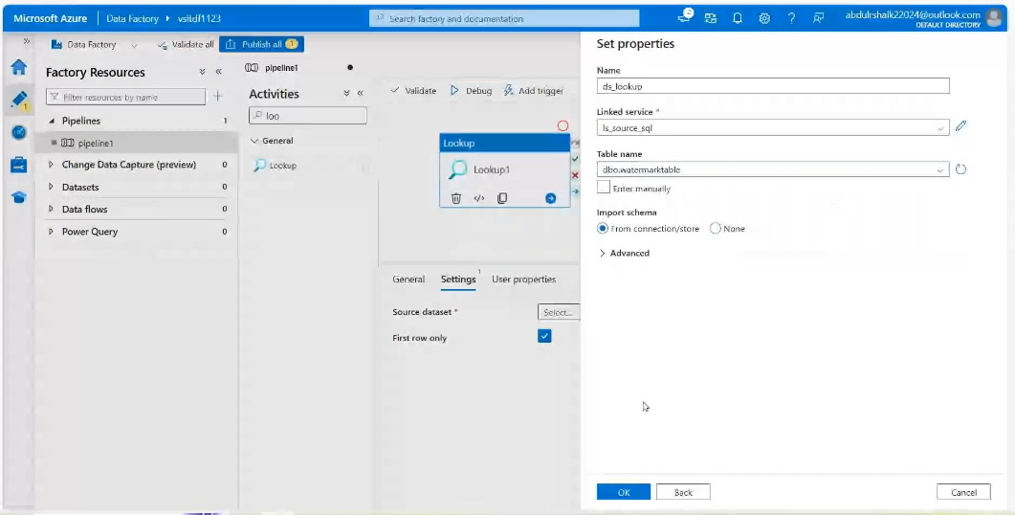
Then Drag and drop the copy data activity:
Source side: create dataset for copy data activity:
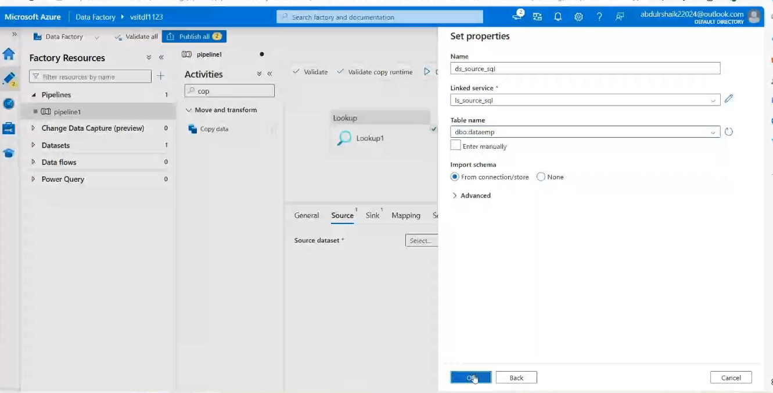
Create dataset for sink side:

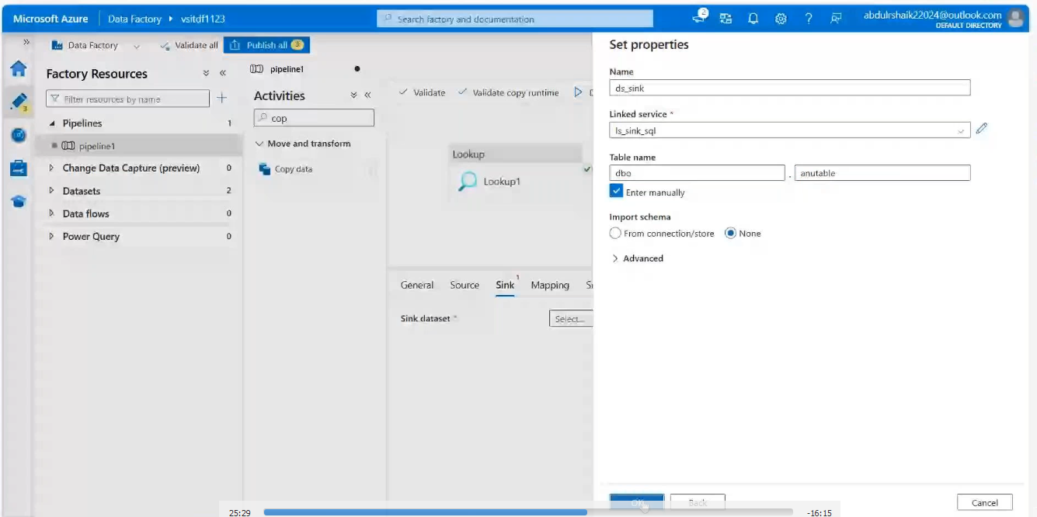
Then source side:
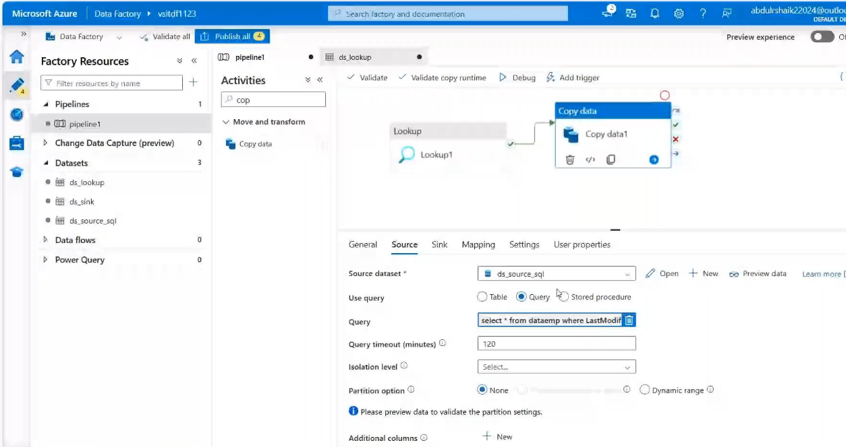
Under query: need to use this query:
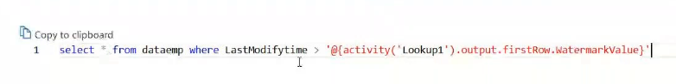
Sink side enable the Auto create table:
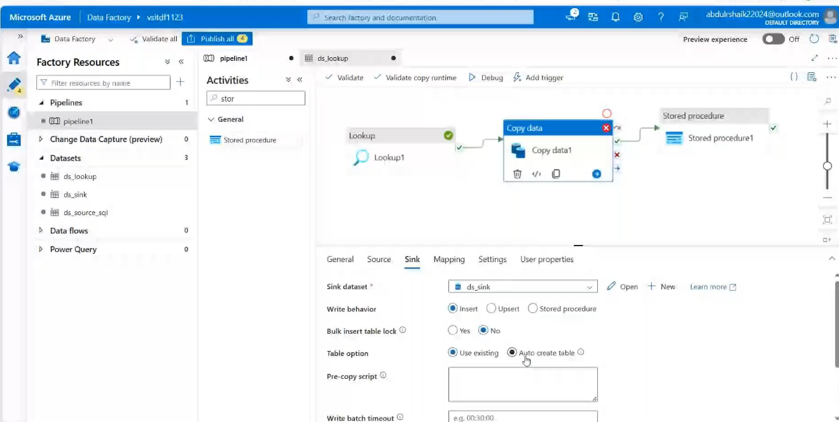
Then Drag and Drop the stored procedure: Add the liked dataset and stored procedure
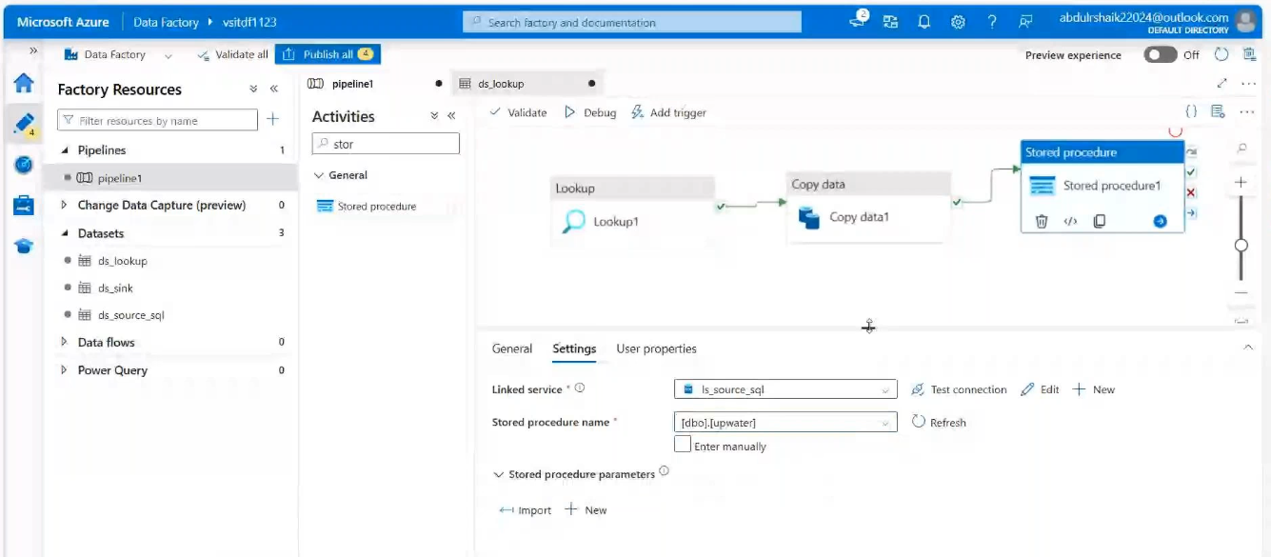
Validate and Debug:
Result:
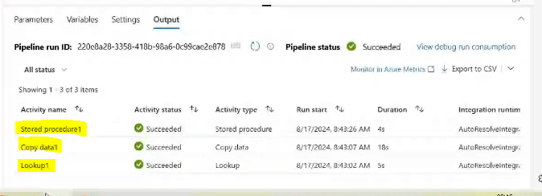
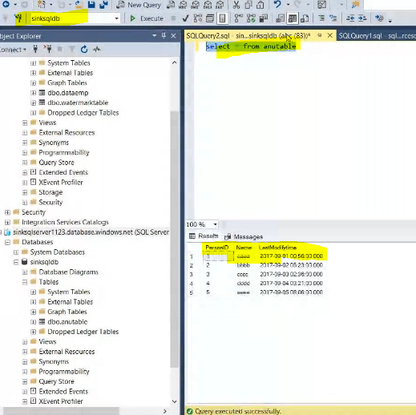
Then add the few more records in source database
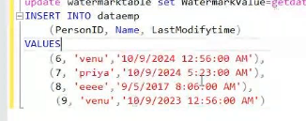
Validate and Debug:
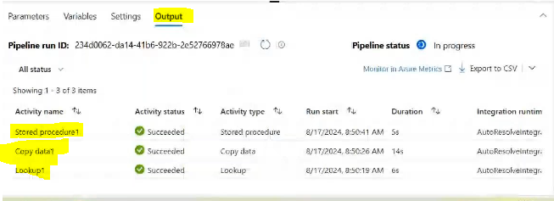
Result;
